Bahria University,

Karachi Campus



Course: CSL 460 – Data Mining

Term: Fall 2022, Class: BSE- 6(B)

Submitted By:

**M Muaz Shahzad 02-131202-081**

(Name) (Reg. No.)

Submitted To:

Mam Rahemeen

Signed Remarks: Score:

INDEX

|  |  |  |  |  |
| --- | --- | --- | --- | --- |
| SNO | DATE | LAB NO | LAB OBJECTIVE | SIGN |
| **01** | **27/2/23** | **01** | **Python Programming** |  |
|  |  |  |  |  |
|  |  |  |  |  |
|  |  |  |  |  |
|  |  |  |  |  |
|  |  |  |  |  |
|  |  |  |  |  |
|  |  |  |  |  |
|  |  |  |  |  |
|  |  |  |  |  |
|  |  |  |  |  |
|  |  |  |  |  |
|  |  |  |  |  |
|  |  |  |  |  |

Bahria University,

Karachi Campus



LAB EXPERIMENT NO.

**01**

LIST OF TASKS

|  |  |
| --- | --- |
| TASK NO | OBJECTIVE |
| 1 | **Take user information as an input from user and print his bio using python.** |
| 2 | **Write Pythonic code to solve the quadratic equation ax**2 + bx + c = 0 by getting input for coefficients from the user.** |
|  |  |
|  |  |
|  |  |

**Task 1: Take user information as an input from user and print his bio using python.**

**Solution:**

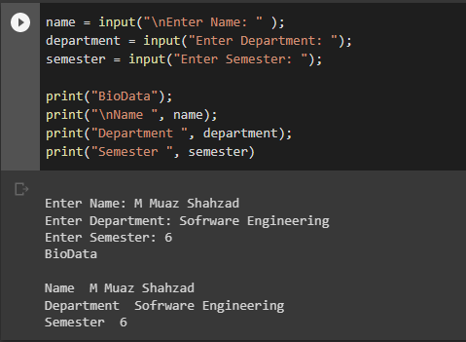

**Task 2: Write Pythonic code to solve the quadratic equation ax**2 + bx + c = 0 by getting input for coefficients from the user.**

**Solution**

